**DAILY ONLINE ACTIVITIES SUMMARY**

|  |  |  |  |  |  |  |  |  |
| --- | --- | --- | --- | --- | --- | --- | --- | --- |
| **Date:** | **06/07/2020** | | | | | **Name:** | **Lavanya D M** | |
| **Sem & Sec** | **4th & ‘A’** | | | | | **USN:** | **4al18cs041** | |
| **Online Test Summary** | | | | | | | | |
| **Subject** | | **----** | | | | | | |
| **Max. Marks** | | **----** | | **Score** | | | **-----** | |
| **Certification Course Summary** | | | | | | | | |
| **Course** | Introduction to Block chain | | | | | | | |
| **Certificate Provider** | | | **Bitdegree** | | **Duration** | | | **4days** |
| **Coding Challenges** | | | | | | | | |
| **Problem Statement:** 1) Write a Java program to find the Nth natural number with exactly two bits set2)  **Write a Java program to print the nodes present in the Circular LinkedList** | | | | | | | | |
| **Status: Complied** | | | | | | | | |
| **Uploaded the report in Github** | | | | | **yes** | | | |
| **If yes Repository name** | | | | | <https://github.com/lavanyamurthi/lockdown-coding> | | | |
| **Uploaded the report in slack** | | | | | **yes** | | | |

Online Test Details: (Attach the snapshot and briefly write the report for the same)

No test conducted

Certification Course Details: (Attach the snapshot and briefly write the report for the same)

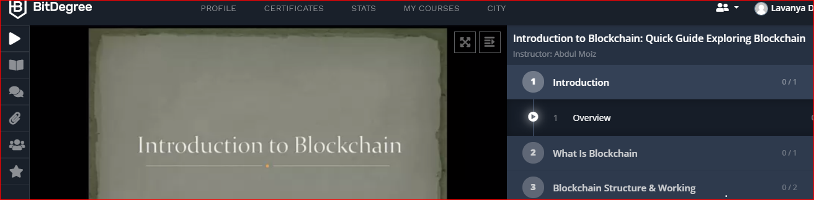

Coding Challenges Details: (Attach the snapshot and briefly write the report for the same)

**Problem 1 :** Write a Java program to find the Nth natural number with exactly two bits setGiven an integer N, the task is to find the Nth natural number with exactly two bits set.

Examples:

Input: N = 4  
Output: 9

Input: N = 15  
Output: 48

**Hint**  
***Explanation: of 1st example***  
Binary representation of numbers 1 -0001, 2- 0010, **3- 0011**, 4-0100, **5-0101**, **6-0110**, 7- 0111, 8-1000, **9 - 1001**, **10- 1010** etc. Here only for the bold numbers binary values contains exactly 2 bits 1's hence  
Numbers with exactly two bits set: 3, 5, 6, 9, 10, 12, …  
4th number in this is 9.

**Therefore output is 9**

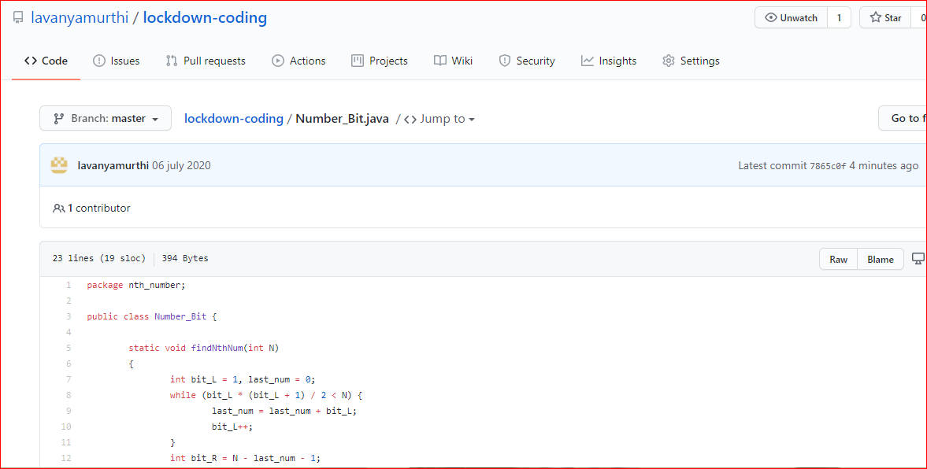

|  |
| --- |
|  |
|  |  |

## **Problem 2:  Write a Java program to print the nodes present in the Circular LinkedList**

